22.50: a) If the nucleus is a uniform positively charged sphere, it is only at its very center where forces on a charge would balance or cancel

b) 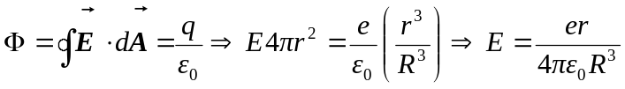
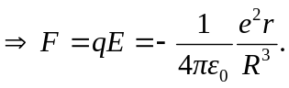
So from the simple harmonic motion equation:

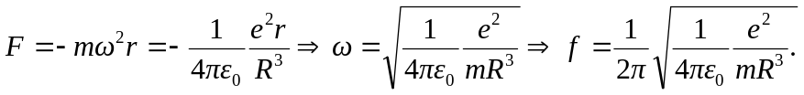

c) If 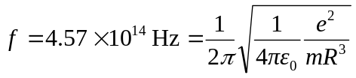

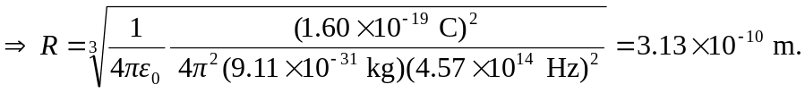

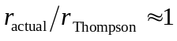
d) If 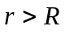 then the electron would still oscillate but not undergo simple harmonic motion, because for 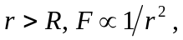 and is not linear.

